**Asteroid Class**

class Asteroid {

private size: number;

private score: number;

private health: number;

private distanceTravelled: number;

public constructor(size: number, score: number, health: number, distanceTravelled: number) {

this.size = size;

this.score = score;

this.health = health;

this.distanceTravelled = distanceTravelled

}

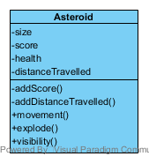

private addScore() {

this.score = this.size

}

private addDistanceTravelled() {

this.distanceTravelled++;

}

movement() {

this.addDistanceTravelled()

console.log(this.addDistanceTravelled);

}

explode() {

this.addScore()

console.log("Boem")

}

visibility() {

this.size;

console.log("Asteroid");

}

}

let spaceRock = new Asteroid(50, 50, -10, 1000)

console.log(spaceRock);

spaceRock.movement();

spaceRock.explode();

spaceRock.visibility();